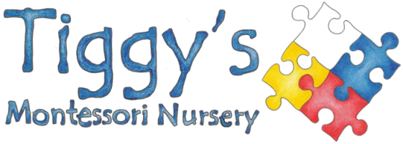
Parent Library Titles
- Learning Together – What Montessori can offer your family
- How to raise an amazing child – the Montessori way to bring up caring, confident children
- Montessori Madness – a parent to parent argument for Montessori education
- Basic Montessori – introduction to the philosophy and explanation of the equipment

- Too Much Too Soon – early learning and the erosion of childhood
- Toxic Childhood – how the modern world is damaging our children and what we can do about it
- Detoxing Childhood – what parents need to know to raise bright and balanced children
- Your Child Your Way by Tanya Byron (Child Psychologist from BBC TV House of Tiny Tearaways)
- The Secret of Happy Children
- Raising Boys
- Raising Girls
- Titles by Steve Biddulph, a psychologist and one of the world’s best known parenting authors

On a light hearted note:

- Toddler Taming – a parent’s guide to the first four years – Christopher Green’s amusing but useful guide
- The politically incorrect parenting book – 10 no nonsense rules to stay sane and raise happy kids

